The graphic below illustrates how an Alliance improves the financial position for a child care center serving 65 children.
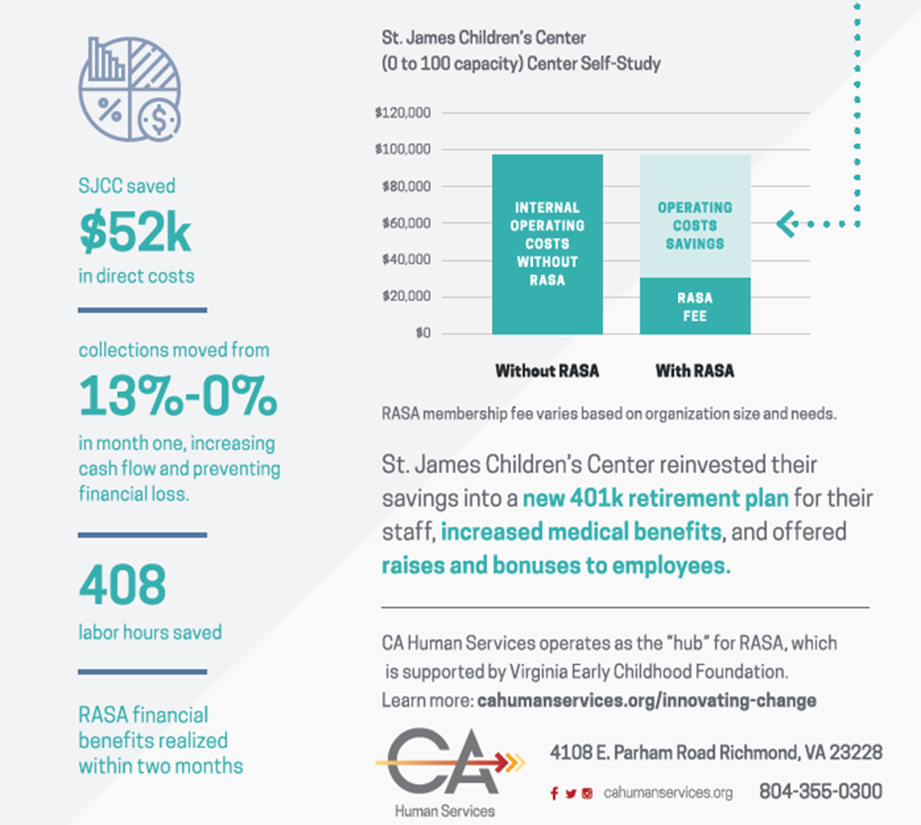

This graphic helps illustrate how business software and back-office services improve provider sustainability:
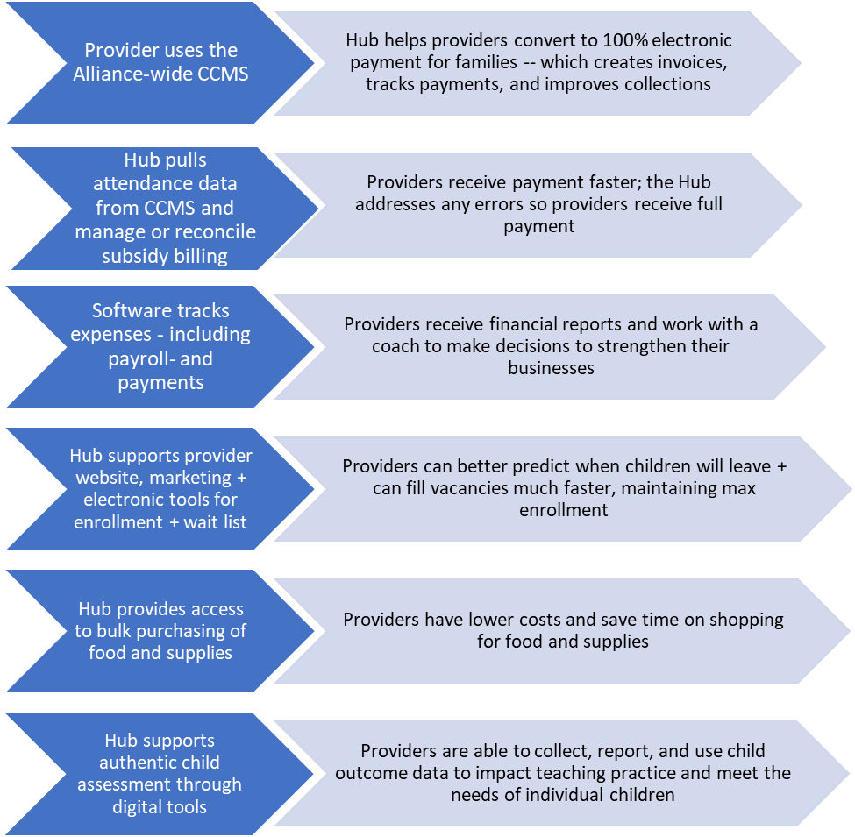

The following screenshots from a Shared Service Alliance Hub clearly articulate the Value Proposition:
