Theory of Change
for
Shared Service Planning

What is It?

A Theory of Change is a project roadmap that helps you get clear about what you are trying to accomplish and the steps it will take to get there. The most effective Networks and Alliances have a laser focus on:
- Provider outcomes,
- Services needed to achieve those outcomes, and
- A way to collect data to measure progress (or lack thereof)

This progression is articulated on the Theory of Change, which creates a structure for measuring progress at the individual provider level and a context for assessing patterns and trends identified in aggregated data.

Example

The example below makes these linkages clear, underscoring that services and Network actions (strategies), are designed to influence specific provider skills and practices (targets), in pursuit of the ultimate goals (outcomes).
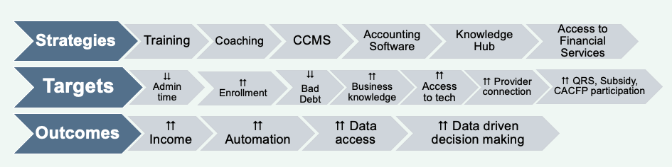

Intermediaries can use the template to create a Theory of Change for their Alliances and Networks, using the following guidance:

Strategies – What is the service or product offered to provider members (either directly or via subcontractors)?

Targets – What are the short-term changes that you expect to measure among your provider members in order to assess the impact of those services and products?

Outcomes – What are the long-term impacts for provider members? What will your provider members experience after a year of membership in your Alliance/Network that they do not currently enjoy?

Instructions for using the template:
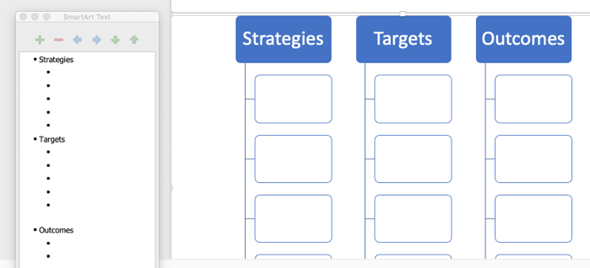
Click on the box below and a
text box will appear.
Click on each bullet
to fill content

